TASK : Install Prometheus and Grafana on a Linux EC2 machine, connect Prometheus to Grafana, and create a dashboard to view metrics.

create a ec2 instance

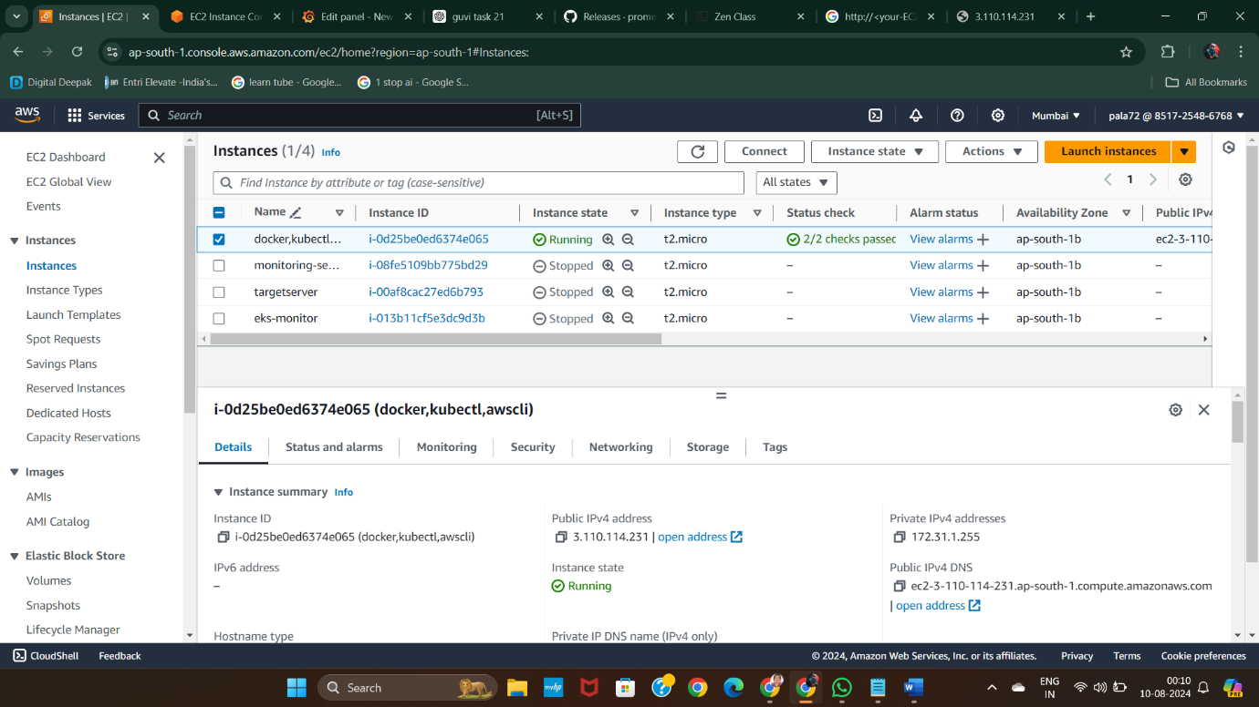

* Then open security group of that instance and open the ports below,

9090: Prometheus 3000: Grafana 22: SSH access

* install Prometheus and check for its status it’s running or not

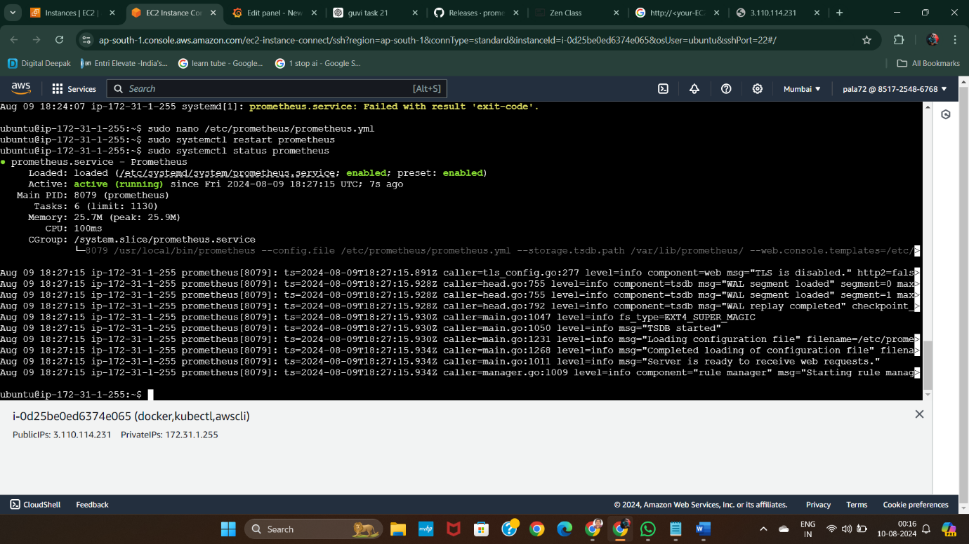

* install Grafana

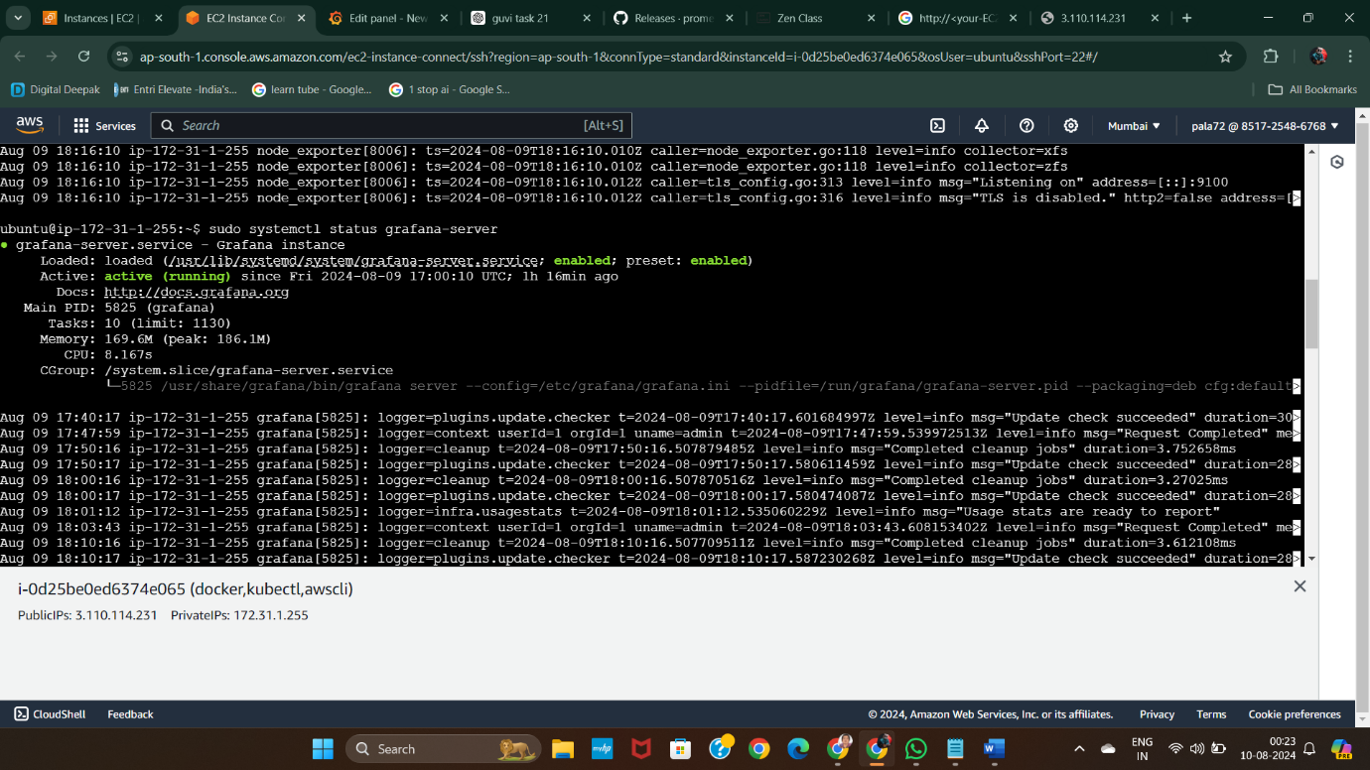

* Download node exporter using the series of steps

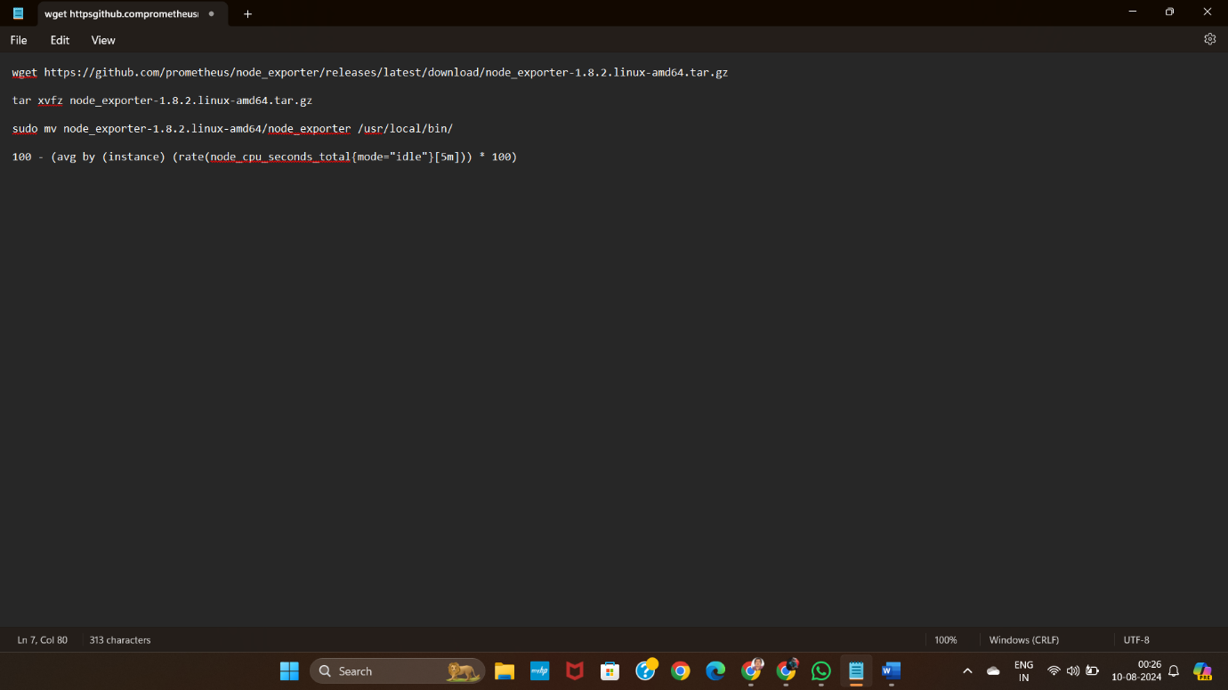

- move binaries and create systemd service file , start and enable node exporter service

Then Configure Prometheus

Scrape configuration for Prometheus itself.

Scrape configuration for Node Exporter.

Create a new dashboard.

Add a new panel and enter the query for CPU usage:

100 - (avg by (instance) (rate(node_cpu_seconds_total{mode="idle"}[5m])) * 100)

Adjust the panel settings and save the dashboard.

